SOFTWARE REQUIREMENTS SPECIFICATION
FOR
RIDE SHARING WITH GPS
Version <1.0>

Revision History
Date | Version | Description | Author | Approved
Mar-3-2015 | 1.0 | Software requirement specification overview level | Terry, Vidal, Harold, Cody, Truman, Hanley
www.enclaveIT.com

Table of contents

1. Introduction 6
1.1 Purpose 7
1.2 Scope 7
1.3 Definitions, Acronyms and Abbreviations 7
1.4 References 7
1.5 Overview 7
2. Overall Description 8
2.1 Use-case Model Survey 8
2.1.1 Use-case diagram 8
2.1.1.1 Administrator - Staff 8
2.1.1.2 User – Customer - Guest 9
2.1.2 Sub Use-case diagram 10
2.1.2.1 Administrator – Staff 10
2.1.2.1.1 Use-case Manage User 10
2.1.2.1.2 Use-case Manage Itinerary 10
2.1.2.1.3 Use-case Manage Feedback 11
2.1.2.1.4 Use-case Manage Payment 11
2.1.2.1.5 Use-case Manage Staff 12
2.1.2.1.6 Use-case Analyze Statistically 12
2.1.2.2 User – Customer – Guest 12
2.1.2.2.1 Use-case Register new account 12
2.1.2.2.2 Use-case Manage account 13
2.1.2.2.3 Use-case View other user profile 13
2.1.2.2.4 Use-case Manage Schedule 13
2.1.2.2.5 Use-case Analyze Statistically 14
2.1.2.2.6 Use-case Manage Itineraries 14
2.1.2.2.7 Use-case View Itineraries 15
3. Specific Requirements 16
3.1 Administrator – Staff 16
3.1.1 Use-case Manage User 16
3.1.1.1 UC001-Create user 16
3.1.1.1.1 Brief Description 16
3.1.1.1.2 Pre-Condition 16
3.1.1.1.3 Post-Condition 16
3.1.1.1.4 Flow of Events 16
3.1.1.2 UC002-View user profile 16
3.1.1.2.1 Brief Description 16
3.1.1.2.2 Pre-Condition 16
3.1.1.2.3 Post-Condition 16
3.1.1.2.4 Flow of Events 16
3.1.1.3 UC003-Delete user 17
3.1.1.3.1 Brief Description 17
3.1.1.3.2 Pre-Condition 17
3.1.1.3.3 Post-Condition 17
3.1.1.3.4 Flow of Events 17
3.1.1.4 UC004-Search user 17
3.1.1.4.1 Brief Description 17
3.1.1.4.2 Pre-Condition 17
3.1.1.4.3 Post-Condition 17
3.1.1.4.4 Flow of Events 17
3.1.1.5 UC005-View details user 18
3.1.1.5.1 Brief Description 18
3.1.1.5.2 Pre-Condition 18
3.1.1.5.3 Post-Condition 18
3.1.1.5.4 Flow of Events 18
3.1.1.6 UC006-Update user 18
3.1.1.6.1 Brief Description 18
3.1.1.6.2 Pre-Condition 18
3.1.1.6.3 Post-Condition 18
3.1.1.6.4 Flow of Events 18
3.1.2 Use-case Manage staff 19
3.1.2.1 UC009-Create staff 19
3.1.2.1.1 Brief Description 19
3.1.2.1.2 Pre-Condition 19
3.1.2.1.3 Post-Condition 19
3.1.2.1.4 Flow of Events 19
3.1.2.2 UC010-View staff 19
3.1.2.2.1 Brief Description 19
3.1.2.2.2 Pre-Condition 19
3.1.2.2.3 Post-Condition 19
3.1.2.2.4 Flow of Events 20
3.1.2.3 UC011-Delete staff 20
3.1.2.3.1 Brief Description 20
3.1.2.3.2 Pre-Condition 20
3.1.2.3.3 Post-Condition 20
3.1.2.3.4 Flow of Events 20
3.1.2.4 UC012-Search staff 20
3.1.2.4.1 Brief Description 20
3.1.2.4.2 Pre-Condition 20
3.1.2.4.3 Post-Condition 20
3.1.2.4.4 Flow of Events 20
3.1.2.5 UC013-View staff details 21
3.1.2.5.1 Brief Description 21
3.1.2.5.2 Pre-Condition 21
3.1.2.5.3 Post-Condition 21
3.1.2.5.4 Flow of Events 21
3.1.2.6 UC014-Update staff 21
3.1.2.6.1 Brief Description 21
3.1.2.6.2 Pre-Condition 21
3.1.2.6.3 Post-Condition 21
3.1.2.6.4 Flow of Events 21
3.1.3 Use-case Manage Payment 22
3.1.4 Use-case Manage Feedback 22
3.2 User – Customer – Guest 23
3.2.1 Use-case Log In 23
3.2.1.1 UC015-Log In 23
3.2.1.1.1 Brief Description 23
3.2.1.1.2 Pre-Condition 23
3.2.1.1.3 Post-Condition 23
3.2.1.1.4 Flow of Events 23
3.2.2 Use-case Log Out 23
3.2.2.1 UC016- Log Out 23
3.2.2.1.1 Brief Description 23
3.2.2.1.2 Pre-Condition 23
3.2.2.1.3 Post-Condition 23
3.2.2.1.4 Flow of Events 23
3.2.3 Use-case Register new account 24
3.2.3.1 UC017- User Register new account 24
3.2.3.1.1 Brief Description 24
3.2.3.1.2 Precondition: 24
3.2.3.1.3 Post Condition: 24
3.2.3.1.4 Flow of Events 24
3.2.4 Use-case Send Feedback 24
3.2.4.1 UC018- Send feedback 24
3.2.4.1.1 Brief Description 24
3.2.4.1.2 Pre-Condition 24
3.2.4.1.3 Post-Condition 24
3.2.4.1.4 Flow of Events 25
3.2.5 Use-case Manage account 25
3.2.5.1 UC019- View profile 25
3.2.5.1.1 Brief Description 25
3.2.5.1.2 Pre-Condition 25
3.2.5.1.3 Post-Condition 25
3.2.5.1.4 Flow of Events 25
3.2.5.2 UC029- Update profile 25
3.2.6 Use-case Manage schedule 25
3.2.6.1 UC001-View schedule 25
3.2.6.1.1 Brief Description 25
3.2.6.1.2 Pre-Condition 25
3.2.6.1.3 Post-Condition 26
3.2.6.1.4 Flow of Events 26
3.2.6.2 UC001-Delete schedule 26
3.2.6.2.1 Brief Description 26
3.2.6.2.2 Pre-Condition 26
3.2.6.2.3 Post-Condition 26
3.2.6.2.4 Flow of Events 26
3.2.7 Use-case View other user profile 26
3.2.7.1 UC001-View other user profile 26
3.2.7.1.1 Brief Description 26
3.2.7.1.2 Pre-Condition 26
3.2.7.1.3 Post-Condition 27
3.2.7.1.4 Flow of Events 27
3.2.7.2 UC001-Comment 27
3.2.7.2.1 Brief Description 27
3.2.7.2.2 Pre-Condition 27
3.2.7.2.3 Post-Condition 27
3.2.7.2.4 Flow of Events 27
3.2.8 Use-case Search Itinerary 27
3.2.8.1 UC002-Search itinerary 27
3.2.8.1.1 Brief Description 27
3.2.8.1.2 Pre-Condition 27
3.2.8.1.3 Post-Condition 27
3.2.8.1.4 Flow of Events 27
3.2.9 Use-case Join an Itinerary 28
3.2.9.1 UC022- Join an Itinerary 28
3.2.9.1.1 Brief Description 28
3.2.9.1.2 Pre-Condition 28
3.2.9.1.3 Post-Condition 28
3.2.9.1.4 Flow of Events 28
3.2.10 Use-case Analyze Statistically 28
3.2.10.1 UC007-View History of Itineraries 28
3.2.10.1.1 Brief Description 28
3.2.10.1.2 Pre-Condition 28
3.2.10.1.3 Post-Condition 28
3.2.10.1.4 Flow of Events 29
3.2.10.2 UC008-View Amount of Money Spent 29
3.2.10.2.1 Brief Description 29
3.2.10.2.2 Pre-Condition 29
3.2.10.2.3 Post-Condition 29
3.2.10.2.4 Flow of Events 29
3.2.11 Use- case View Itinerary 29
3.2.12 Use-case Manage Itineraries 29
4. Supporting Information 30

Introduction
This section gives a scope description and overview of everything included in this SRS document. Also, the purpose of this document is described and a list of abbreviations and definitions is provided.

Purpose
The purpose of this document is to give a detailed description of the requirements for the “Ride Sharing with GPS” software. It will illustrate the purpose and complete declaration for the development of system. It will also explain system constraints, interface and interactions with other external application. This document is primarily intended to be proposed to a customer for its approval and a reference for developing the first version of the system for development team.

Scope
The “Ride Sharing with GPS” includes a GPS- based mobile application and a desktop application which help user to work with posting, searching and join to user else has the same schedule.
By using the GPS, the application can get the current position of users to check the state of them during schedule.

Definitions, Acronyms and Abbreviations
Term | Definition
GPS | Global Positioning System
SRS | Software requirement specification

References
[1] TR-TL-002-Software Requirements Specification (with use cases)

Overview
The remainder of this document includes three chapters. The second one describes the general factors that affect the product and its requirement. This section does not state specific requirements. Instead, it provides a background for those requirements, which are defined in detail in Section 3, and make them easier to understand. Include such items as product perspective, product functions, constraints, assumptions and dependencies, and requirements subsets.
The third chapter provides all software requirements to a level of detail sufficient to enable designers to design a system to satisfy those requirements and testers to test that the system satisfies those requirements.
The last chapter provides supporting information includes table of contents, index and appendices.

Overall Description

Use-case Model Survey

Use-case diagram

Administrator - Staff

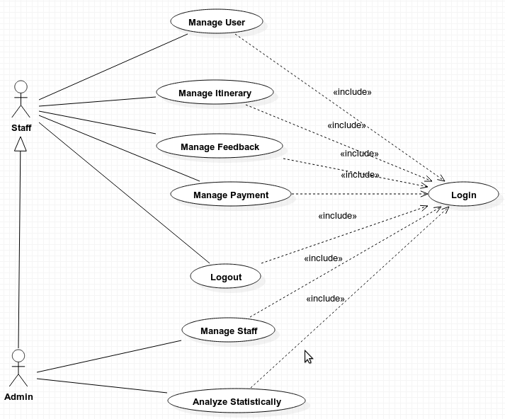

User – Customer - Guest
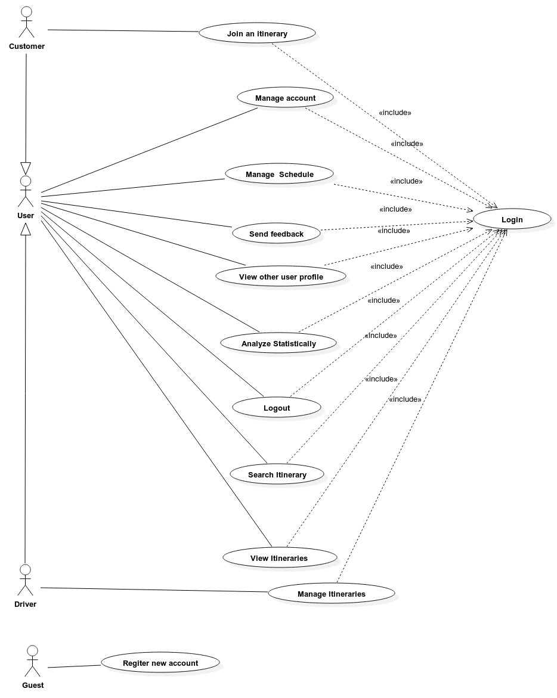

Sub Use-case diagram

Administrator – Staff

Use-case Manage User
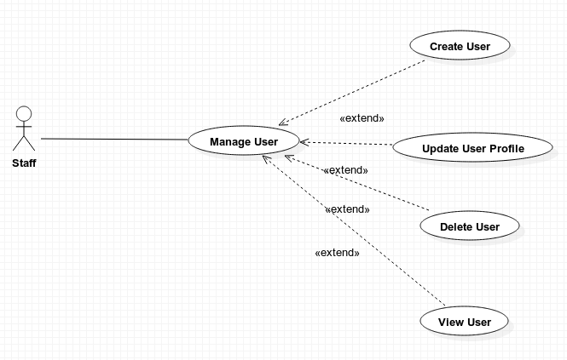

Use-case Manage Itinerary
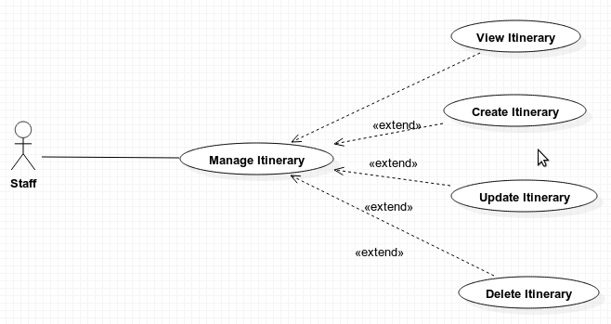

Use-case Manage Feedback
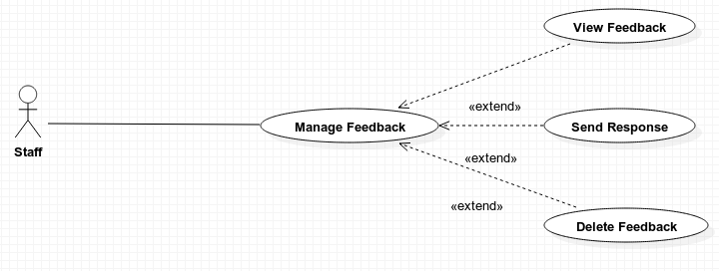

Use-case Manage Payment

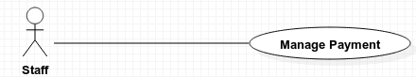

Use-case Manage Staff
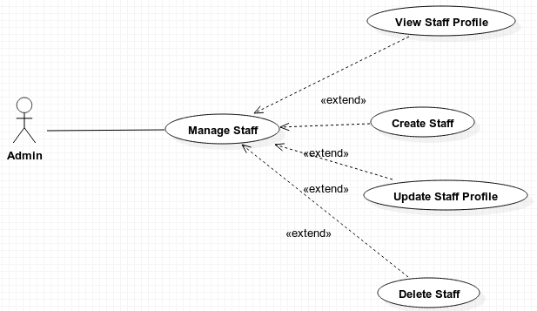

Use-case Analyze Statistically
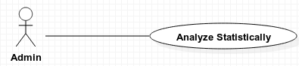

User – Customer – Guest

Use-case Register new account
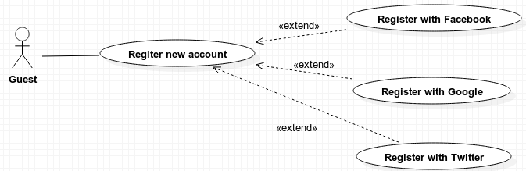

Use-case Manage account
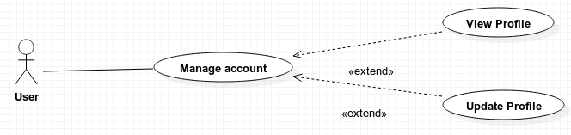

Use-case View other user profile
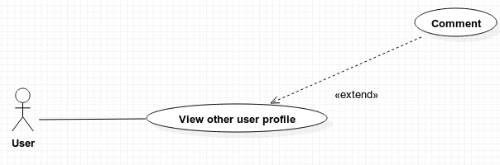

Use-case Manage Schedule

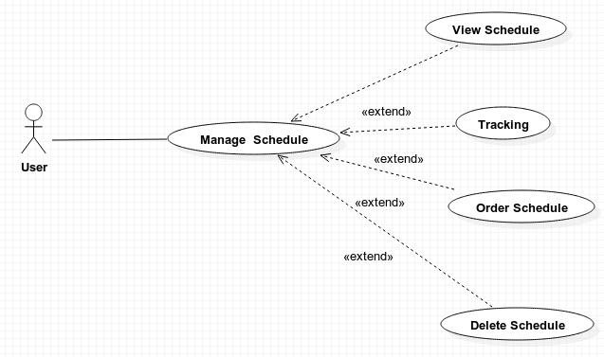

Use-case Analyze Statistically
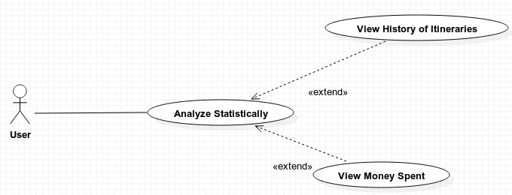

Use-case Manage Itineraries
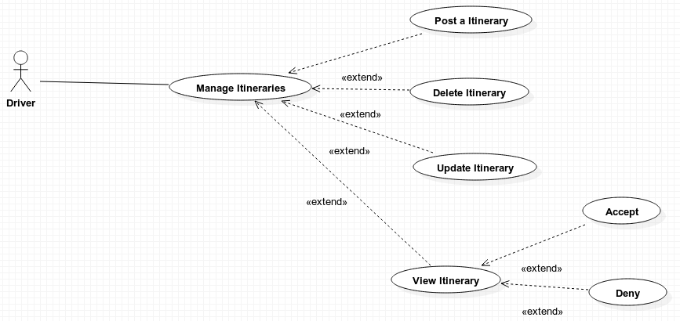

Use-case View Itineraries
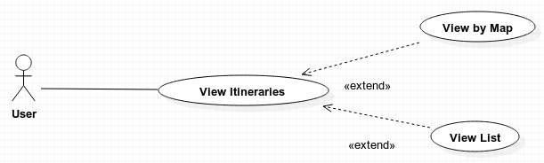

Specific Requirements
This section contains all of the functional and quality requirements of the system. It gives a detailed description of the system and all its features.

Administrator – Staff

Use-case Manage User
Priority: High

UC001-Create user

Brief Description
This Use-case allows user create a new user account.

Pre-Condition
The user has accessed manage user main screen.

Post-Condition
A new user account is saved into the database.

Flow of Events
Step | Description
1 | Staff click “Create user” section.
2 | The screen is displayed some field to fill the information.
3 | Write the information, what is necessary at the field.
4 | User click on “Create new user” button.
5 | Screen display message: “Are you sure?”
6 | Staff click “OK” button
7 | Update database

UC002-View user profile

Brief Description
This Use-case allows staff to view list of user profile.

Pre-Condition
The user has accessed manage user main screen.

Post-Condition
Screen will display list of user account.

Flow of Events
Step | Description
1 | Staff click “View user” section.
2 | The screen is displayed list of user profile.

UC003-Delete user

Brief Description
This Use-case allows user delete one, many or all of user profile. Having two ways to do that. The first way is use can choose and delete user when they are using View user function. The second way is use can delete the current receiving when use View details user function.

Pre-Condition
The user has accessed Manage user main screen.

Post-Condition
Database is updated.

Flow of Events

Step | Description
1 | User choose the user in List User or Detail User that they want to delete
2 | Click “Delete” button
3 | System will display message: “Do you want to delete?”
4 | User click “Yes” button
5 | Update database

UC004-Search user

Brief Description
This Use-case allows user search user by name, date time.

Pre-Condition
The user has accessed manage user main screen.

Post-Condition
Display all of result about user with key word was entered.

Flow of Events
Step | Description
1 | User choose the type of key word that they want to search for. They are name, date time.
2 | User enter the key word into the text field
3 | User click “Search” button
4 | System will display all result on the screen

UC005-View details user

Brief Description
This Use-case allows user review the details of any user. This function is used after user use View user.

Pre-Condition
The user has accessed Manage user main screen.

Post-Condition
The details of user that is chosen will display on the screen.

Flow of Events
Step | Description
1 | User click on the user record that they want to review
2 | System display details of the user that was chosen

UC006-Update user

Brief Description
This Use-case allows user edit the content of user. Having two ways to do it. The first way is when user use View user function, they choose one of user and edit it. The second way is when user use View details user function, they can edit this user.

Pre-Condition
The user has accessed Manage user main screen.

Post-Condition
Database is updated.

Flow of Events

Step | Description
1 | User choose a user in the list of user that they want to edit
2 | Click “Edit” button
3 | System will display screen allows user edit
4 | User edit information they want
5 | Click “Save” button

Use-case Manage staff
Priority: High

UC009-Create staff

Brief Description
This Use-case allows user create a new staff.

Pre-Condition
The user has accessed manage staff main screen.

Post-Condition
A new staff record is saved into the database.

Flow of Events
Step | Description
1 | User click on “Create” button
2 | The screen of itinerary is displayed
3 | User fill in information.
4 | User click on “Save” button
7 | System display message: “Are you sure?”
8 | User click “Yes” button
9 | System handle the data and display information of itinerary on the table
11 | Update database

UC010-View staff

Brief Description
This Use-case allows user review the staff of system. Having options about filling some basic information. It’s a list of staff was created in the system.

Pre-Condition
The user has accessed Manage staff main screen.

Post-Condition
A list of staff in the system are displayed.

Flow of Events
Step | Description
1 | User fill in basic information
2 | System will display a list of all staff

UC011-Delete staff

Brief Description
This Use-case allows user delete one, many or all of staff. Having two ways to do that. The first way is use can choose and delete staff when they are using View staff function. The second way is use can delete the current receiving when use View details staff function.

Pre-Condition
The user has accessed Manage staff main screen.

Post-Condition
Database is updated.

Flow of Events
Step | Description
1 | User choose the staff in List Staff or Detail Staff that they want to delete
2 | Click “Delete” button
3 | System will display message: “Do you want to delete?”
4 | User click “Yes” button
5 | Update database

UC012-Search staff

Brief Description
This Use-case allows user search staff by Name or by Personal ID.

Pre-Condition
The user has accessed manage staff main screen.

Post-Condition
Display all of result about staff with key word was entered.

Flow of Events
Step | Description
1 | User choose the type of key word that they want to search for.
2 | User enter the key word into the text field
3 | User click “Search” button
4 | System will display all result on the screen

UC013-View staff details

Brief Description
This Use-case allows user review the details of any staff. This function is used after user use View staff.

Pre-Condition
The user has accessed Manage staff main screen.

Post-Condition
The details of staff that is chosen will display on the screen.

Flow of Events
Step | Description
1 | User click on the staff record that they want to review
2 | System display details of the staff that was chosen

UC014-Update staff

Brief Description
This Use-case allows user edit the content of staff profile. Having two ways to do it. The first way is when user use View staff function, they choose one of staff and edit it. The second way is when user use View details staff function, they can edit this staff.

Pre-Condition
The user has accessed Manage staff main screen.

Post-Condition
Database is updated.

Flow of Events
Step | Description
1 | User choose the staff in the staff list that they want to edit
2 | Click “Edit” button
3 | System will display screen allows user edit
4 | User edit information they want
5 | Click “Save” button

Use-case Manage Payment

Use-case Manage Feedback

User – Customer – Guest

Use-case Log In

UC015-Log In
Priority: High

Brief Description
This use case allow user to connect into this application.

Pre-Condition
The user have to register to login.

Post-Condition
The main screen is displayed.

Flow of Events
Step | Description
1 | Type User Name and Password in “User Name” field and “Password” field
2 | Click the “Log in” button.
3 | Application's main screen is displayed in the screen.

Use-case Log Out

UC016- Log Out
Priority: High

Brief Description
This Use-case allows user log out their account from application.

Pre-Condition
User have to log in and open the function menu.

Post-Condition
Go back to the log in and register screen.

Flow of Events
Step | Description
1 | User click to the “Log out” Section.
2 | Screen is displayed “Do you want to log out?”
3 | User click “Yes” button
4 | Go back to the log and register screen.

Use-case Register new account

UC017- User Register new account
Priority: High

Brief Description
This user-case is for the user registration. A user must register before they are able to log on the system. Registration primarily consists of entering an email address for verification and creating a password

Precondition:
User is not a member of the system

Post Condition:
User is a member of the system

Flow of Events

Step | Description
1 | User enters their email address and password, and the conformation password
2 | System validates that the email does not already exists. If it does not, a new user is created and a confirmation email is sent with a confirmation link that needs to be selected before the user is allowed to enter the system .
3 | User checks their email for the email that the system sent and gets the confirmation link. The user selects the confirmation link.
4 | System accepts the confirmation link and requests the user to log in using their email and password

Use-case Send Feedback

UC018- Send feedback

Brief Description
This Use-case allows user or rider to send anything about application to administrator .

Pre-Condition
User have open the function menu.

Post-Condition
Display the text field and button “Send” in order to write user’s feedback.

Flow of Events
Step | Description
1 | User click to the “Feedback” Section.
2 | Screen is displayed the Feedback text field and buttons is : “Send feedback”.
3 | User write feedback in the text field.
4 | User click “Send feedback” button to send the feedback.
5 | The screen will display: “Are you sure?”
6 | Click “Yes” button to send or “No” button to cancel.

Use-case Manage account
Priority: High

UC019- View profile

Brief Description
This use case allow user to view and manage their profile.

Pre-Condition
The user who already logged account then click on Account Management Menu.

Post-Condition
User profile will display in the screen.

Flow of Events
Step | Description
1 | Choose the User's Profile field.
2 | User's profile is displayed on the screen.

UC029- Update profile

Use-case Manage schedule
Priority: High

UC001-View schedule

Brief Description
This Use-case allows user view schedule.

Pre-Condition
The user has login to application.

Post-Condition

Flow of Events
Step | Description
1 | User click on “Menu” button
2 | The screen of menu is displayed
3 | User click on “Schedule” button on menu
4 | The list of Schedule is displayed

UC001-Delete schedule

Brief Description
This Use-case allows user delete schedule.

Pre-Condition
The user has login to application.
The user has accessed “View schedule” screen

Post-Condition
Database is updated.

Flow of Events
Step | Description
1 | User click on schedule need to delete
2 | The action button for this schedule is displayed
3 | Use click “Delete” button
4 | System will display message: “Do you want to delete?”
5 | User click “Yes” button
6 | Update database

Use-case View other user profile

UC001-View other user profile

Brief Description
This Use-case allows user view other profile.

Pre-Condition
The user has login to application.
The user has accessed “Itinerary detail” screen

Post-Condition

Flow of Events
Step | Description
1 | User click on the name of other user
2 | The screen of profile of another user is displayed

UC001-Comment

Brief Description
This Use-case allows user comment about another user.

Pre-Condition
The user has login to application.
The user has accessed “Itinerary detail” screen

Post-Condition
A new comment is saved into the database.

Flow of Events
Step | Description
1 | User click on the name of other user
2 | The screen of profile of another user is displayed
3 | Use click on “Comment” button
4 | User type comment content
5 | User click on “Send” button
6 | User’s comment is displayed
11 | Update database

Use-case Search Itinerary

UC002-Search itinerary

Brief Description
This use-case allows user search itinerary by date-time or by Address or by Name of rider or by Money.

Pre-Condition
The user has accessed Customer main screen.

Post-Condition
Display all of result about itinerary with key word was entered.

Flow of Events
Step | Description
1 | User choose the type of key word that they want to search for. They are Address, Name of rider, Money or date-time.
2 | User enter the key word into the text field
3 | User click “Search” button
4 | System will display all result on the screen

Use-case Join an Itinerary

UC022- Join an Itinerary

Brief Description
This use-case allows customer join an itinerary.

Pre-Condition
The user has accessed Customer main screen.

Post-Condition
A request message is sent to rider.

Flow of Events
Step | Description
1 | User click on “Send a request” button
2 | System display message: “Are you sure?”
3 | User click “Yes” button
4 | System handle the request

Use-case Analyze Statistically
Priority: High

UC007-View History of Itineraries

Brief Description
This Use-case allows user view the list of itinerary in the past.

Pre-Condition
The user has open the function menu.

Post-Condition
A list of itinerary in the past of system are displayed.

Flow of Events
Step | Description
1 | User click on “Analyze Statistically” section on menu.
2 | The screen of Analyze Statistically is displayed
3 | User click on “History of Itineraries” button.
4 | System will display list of itinerary in the past.

UC008-View Amount of Money Spent

Brief Description
This Use-case allows user view the amount of money has been spent.

Pre-Condition
The user has open the function menu.

Post-Condition
A total amount of money and the amount of money for each itinerary are displayed.

Flow of Events
Step | Description
1 | User click on “Analyze Statistically” section on menu.
2 | The screen of Analyze Statistically is displayed
3 | User click on “Amount of Money Spent” button.
4 | System will display A total amount of money and the amount of money for each itinerary.

Use- case View Itinerary

Use-case Manage Itineraries

Supporting Information

